SIMATS ENGINEERING

ASSESSMENT TOOL 2

COURSE NAME: Database Management Systems COURSE CODE: CSA0504

COURSE OUTCOME COVERED

CO3: Analyze relational databases using functional dependencies, normalization (1NF to 5NF), and key constraints to identify redundancy and ensure data integrity. (BL2, BL3)

Activity Tool : Case Study (Medium) Assessment Tool Weightage: 30%

QUESTIONS Total Marks: 50
Q.N  o | Question | Bloom's Level | Marks
1 | Analyze the case: An online shopping platform stores Order(OrderID, CustID, CustName, ProdID, ProdName, Qty, Price). Identify FDs and normalize to 3NF. | BL2 – Understand | 5
2 | A hospital maintains Patient(PID, PName, DocID, DocName, Specialization, WardNo, WardName). Identify anomalies and normalize to BCNF. | BL3 – Apply | 5
3 | Case study: A university stores Enrollment(SID, SName, CourseID, CourseName, Faculty, Grade). Analyze FDs and apply 2NF decomposition. | BL3 – Apply | 5
4 | Given the airline booking case: Booking(FlightNo, PassID, PassName, Seat, DeptCity, ArrCity, Date). Normalize up to BCNF. | BL3 – Apply | 5
5 | Analyze an HR system schema for a multinational company. Identify all functional and transitive dependencies and normalize to 3NF. | BL2 – Understand | 5
6 | Case: Library(MemberID, MemberName, BookID, Title, Author, Genre, BorrowDate). Identify MVDs and decompose to 4NF. | BL3 – Apply | 5

7 | Analyze a telecom billing schema and identify all candidate keys, primary keys, and functional dependencies before normalization. | BL2 – Understand | 5
8 | A retail inventory system has Product(PID, PName, SupplierID, SupplierName, Category, Price, Warehouse). Apply complete normalization. | BL3 – Apply | 5
9 | Study the given poorly normalized schema for a School ERP and propose a fully normalized design up to BCNF with justification. | BL3 – Apply | 5
10 | Given a movie streaming platform schema, identify join dependencies and decompose to 5NF with lossless-join verification. | BL3 – Apply | 5

Code of Conduct:

I Shaik Mahamad Sohail (192511120) certify that this submission is my original work and that I have adhered to the guidelines specified for this assessment. I understand that any violation of academic integrity rules will result in disciplinary action.

Signature of the student: 

RUBRICS FOR CALCULATION:

Criteria | Level 4 – Exemplary | Level 3 – Proficient | Level 2 – Developing | Level 1 – Beginning
Understandin g of Case | Thorough  understanding  ; clearly identifies all key issues | Good  understanding with most issues identified | Basic  understanding  ; some issues missed | Poor  understanding  ; problem not identified  correctly
Application of Concepts | Effectively applies relevant  concepts to analyze the case deeply | Applies  appropriate concepts with minor gaps | Limited  application of concepts | Fails to apply relevant concepts
Analysis | In-depth  analysis with strong  reasoning and insights | Good analysis with logical reasoning | Basic analysis with limited depth | Weak or no analysis; lacks  reasoning

Solution Design | Innovative, feasible  solutions with strong  justification | Logical solutions with adequate  justification | Basic solutions with weak  justification | Incorrect or no solution  provided
Clarity | Clear,  well-structure d, and easy to understand | Organized and understandabl e presentation | Limited clarity and structure | Poor clarity; difficult to understand

1. Analyze the case: An online shopping platform stores Order(OrderID, CustID, CustName, ProdID, ProdName, Qty, Price). Identify FDs and normalize to 3NF.
ANS:
Given Relation
ORDER(OrderID, CustID, CustName, ProdID, ProdName, Qty, Price)

Understanding attributes
Attribute | Meaning
OrderID | Unique order number
CustID | Customer ID
CustName | Customer name
ProdID | Product ID
ProdName | Product name
Qty | Quantity ordered
Price | Price of the product

Assume that one order can contain multiple products.
Example:
OrderID | CustID | CustName | ProdID | ProdName | Qty | Price
O101 | C01 | Ravi | P01 | Laptop | 1 | 50000
O101 | C01 | Ravi | P02 | Mouse | 2 | 1000
O102 | C02 | Anu | P01 | Laptop | 1 | 50000

Primary Key
Because an order can contain multiple products, OrderID alone is not sufficient.
Therefore:
Primary Key = (OrderID, ProdID)
It is a composite primary key.

Functional Dependencies
From the meaning of the attributes:
FD 1 – Customer
A customer ID determines the customer's name:
CustID → CustName

FD 2 – Product
A product ID determines the product name and price:
ProdID → ProdName, Price

FD 3 – Order Item
The combination of order and product determines the quantity:
(OrderID, ProdID) → Qty

Therefore, write all FDs as:
CustID → CustName

ProdID → ProdName, Price

(OrderID, ProdID) → Qty

Check 1NF
A table is in 1NF when every attribute contains atomic/single values.
Our relation contains single values in every cell.
Therefore:
ORDER is in 1NF.
So we have:
ORDER(OrderID, CustID, CustName, ProdID, ProdName, Qty, Price)

Check 2NF
The primary key is:
(OrderID, ProdID)
Now check whether any non-key attribute depends on only part of this composite key.
We have:
ProdID → ProdName, Price

Convert to 2NF
Create three tables.

1. CUSTOMER
CUSTOMER(CustID, CustName)
Primary key:
CustID

2. PRODUCT
PRODUCT(ProdID, ProdName, Price)
Primary key:
ProdID

3. ORDER_DETAILS
ORDER_DETAILS(OrderID, CustID, ProdID, Qty)
Primary key:
(OrderID, ProdID)
Foreign keys:
CustID → CUSTOMER(CustID)
ProdID → PRODUCT(ProdID)

Check 3NF
CUSTOMER
CustID → CustName
CustID is the primary key.
Therefore, CUSTOMER is in 3NF.

PRODUCT
ProdID → ProdName, Price
ProdID is the primary key.
Therefore, PRODUCT is in 3NF.

ORDER_DETAILS
(OrderID, ProdID) → Qty
The determinant is the primary key.
Therefore, ORDER_DETAILS is in 3NF.

Final 3NF Design

CUSTOMER
-------------------
CustID PK
CustName

PRODUCT
-------------------
ProdID PK
ProdName
Price

ORDER_DETAILS
-------------------
OrderID PK
CustID FK
ProdID FK
Qty

PK = (OrderID, ProdID)

Relationship:

CUSTOMER
|
| 1 : M
↓
ORDER_DETAILS
↑
| M : 1
|
PRODUCT
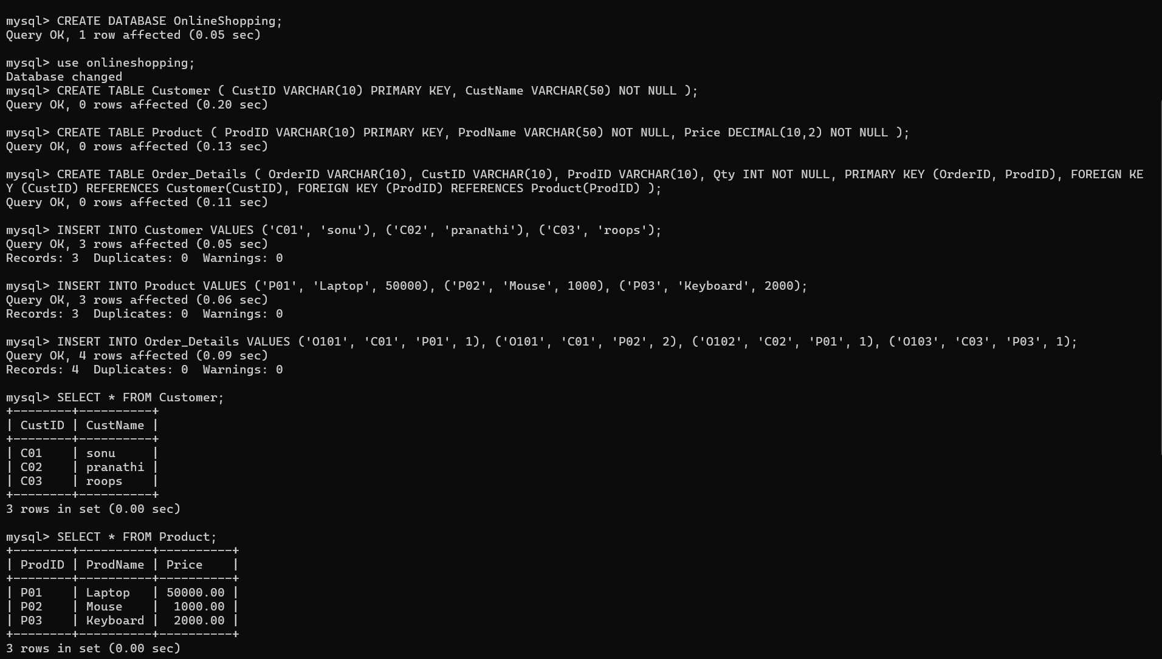

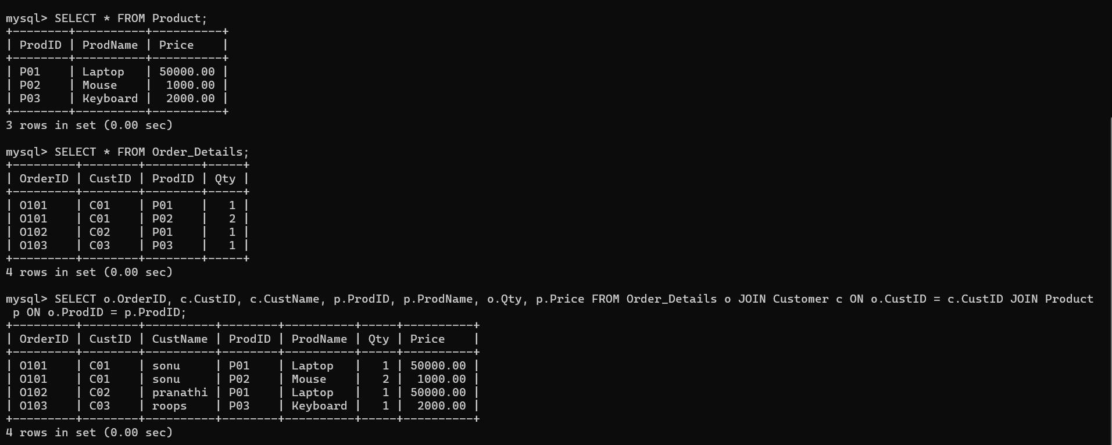

Result:
The given ORDER relation has the functional dependencies CustID → CustName, ProdID → ProdName, Price, and (OrderID, ProdID) → Qty. The composite key is (OrderID, ProdID). The relation is initially in 1NF but contains partial dependencies, so it is decomposed into CUSTOMER, PRODUCT, and ORDER_DETAILS. The resulting relations are in 3NF because every non-key attribute depends on the key, the whole key, and nothing but the key. The decomposition reduces redundancy and prevents insertion, update, and deletion anomalies.

2. A hospital maintains Patient(PID, PName, DocID, DocName, Specialization, WardNo, WardName). Identify anomalies and normalize to BCNF.
ANS:

Given Relation
PATIENT(PID, PName, DocID, DocName, Specialization, WardNo, WardName)

Primary Key
PK = PID

Functional Dependencies
PID → PName, DocID, WardNo
DocID → DocName, Specialization
WardNo → WardName

Anomalies
- Update: Doctor/ward details must be updated in multiple rows.
- Insertion: A new doctor cannot be stored without a patient.
- Deletion: Deleting the last patient may delete doctor/ward information.

1NF
All attributes contain atomic values.
✓ 1NF

2NF
PID is a single-attribute key, so there are no partial dependencies.
✓ 2NF

3NF Check
Transitive dependencies exist:
PID → DocID → DocName, Specialization
PID → WardNo → WardName
Therefore:
✗ Not in 3NF

Decompose to BCNF
PATIENT(PID, PName, DocID, WardNo)
DOCTOR(DocID, DocName, Specialization)
WARD(WardNo, WardName)

Keys:
PATIENT → PID
DOCTOR → DocID
WARD → WardNo

BCNF Verification
PID → PName, DocID, WardNo
DocID → DocName, Specialization
WardNo → WardName

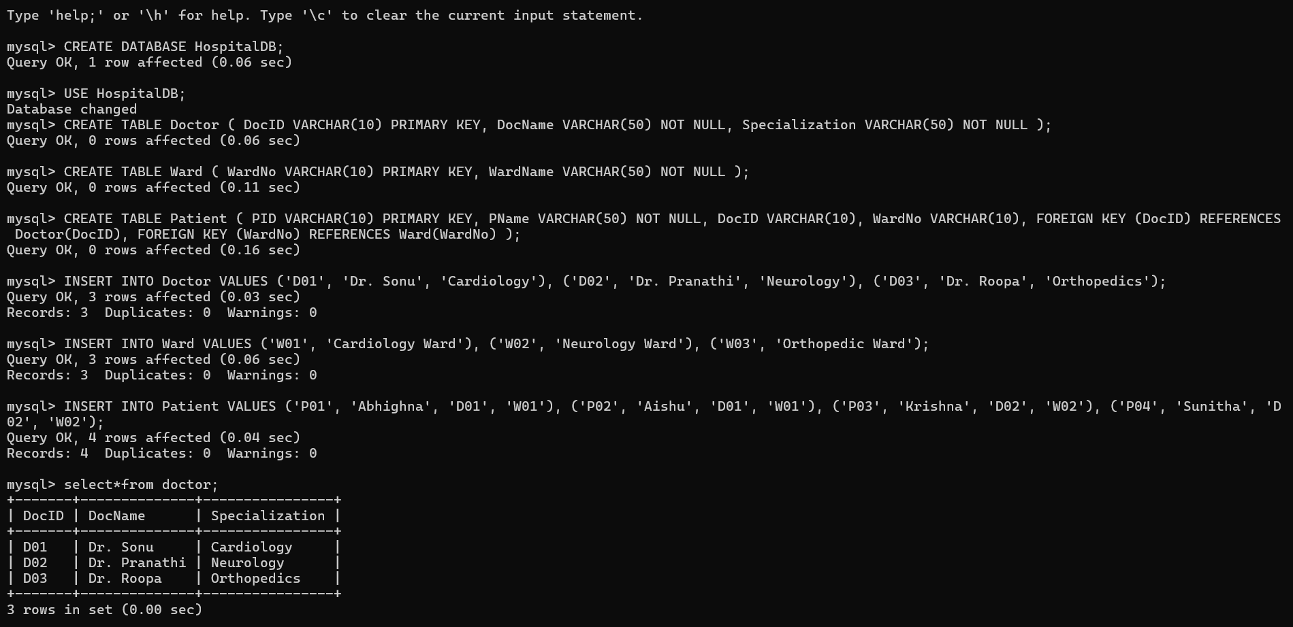
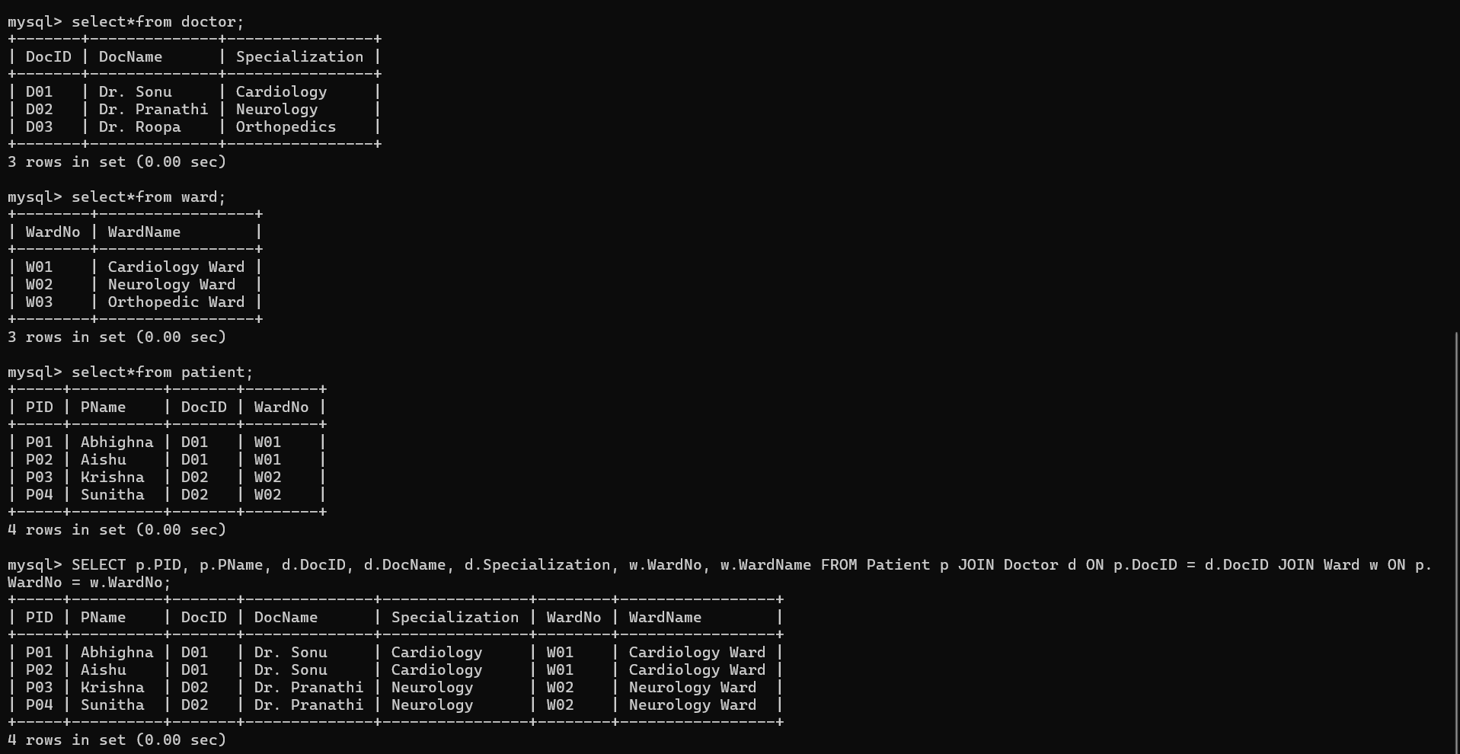
Result:
The original relation has update, insertion and deletion anomalies due to redundancy. Decomposing it into PATIENT, DOCTOR and WARD removes transitive dependencies and produces a BCNF design.

3. A university stores Enrollment(SID, SName, CourseID, CourseName, Faculty, Grade). Analyze FDs and apply 2NF decomposition.
ANS:

Given Relation
ENROLLMENT(SID, SName, CourseID, CourseName, Faculty, Grade)

Functional Dependencies
SID → SName
CourseID → CourseName, Faculty
(SID, CourseID) → Grade

Primary Key
Since a student can enroll in multiple courses:
Primary Key = (SID, CourseID)
It is a composite key.

1NF Analysis
The relation is in 1NF because all attributes contain atomic values and there are no repeating groups.
✓ 1NF

Identify Partial Dependencies
The composite key is:
(SID, CourseID)
But:
SID → SName
SName depends only on SID.
Also:
CourseID → CourseName, Faculty
CourseName and Faculty depend only on CourseID.
Therefore, partial dependencies exist.
✗ Not in 2NF

2NF Decomposition
STUDENT
STUDENT(SID, SName)
Primary Key: SID

COURSE
COURSE(CourseID, CourseName, Faculty)
Primary Key: CourseID

ENROLLMENT
ENROLLMENT(SID, CourseID, Grade)
Primary Key: (SID, CourseID)

Foreign Keys:
SID → STUDENT(SID)
CourseID → COURSE(CourseID)

Final 2NF Schema

STUDENT
----------------
SID (PK)
SName

COURSE
----------------
CourseID (PK)
CourseName
Faculty

ENROLLMENT
----------------
SID (FK)
CourseID (FK)
Grade

PK = (SID, CourseID)

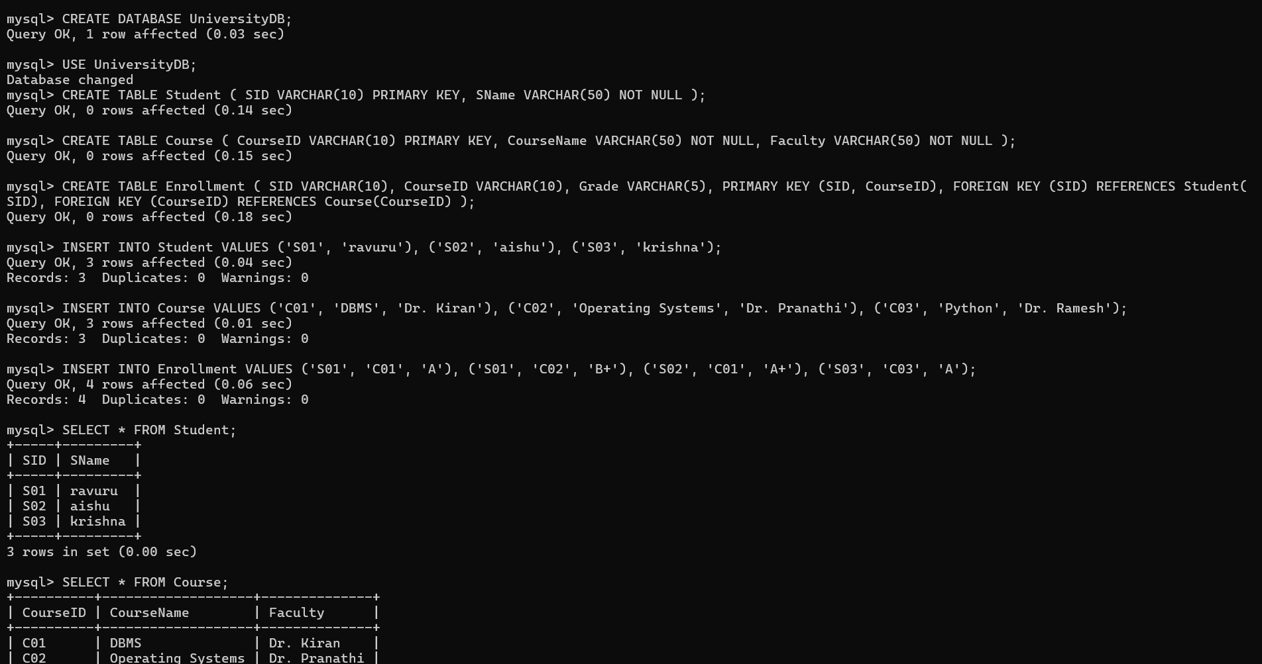

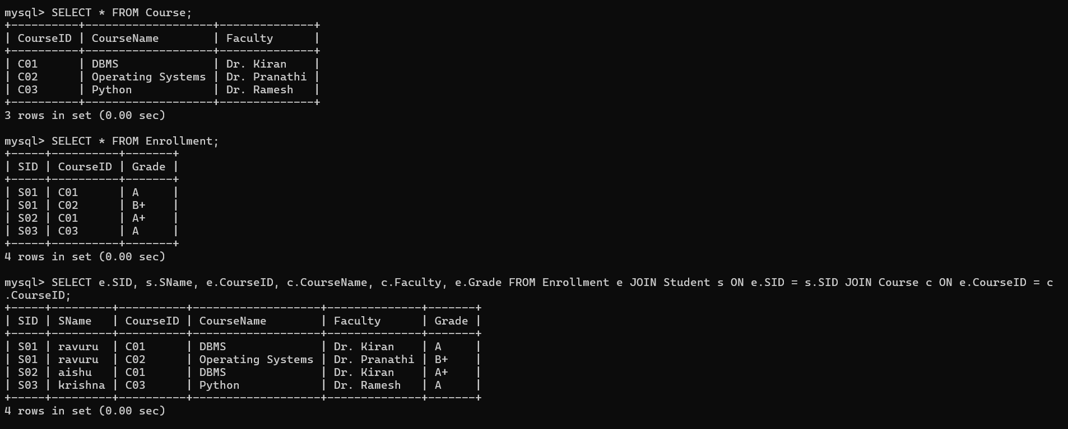
Result:
The ENROLLMENT relation has partial dependencies because SName depends only on SID, while CourseName and Faculty depend only on CourseID. Therefore, the relation is not in 2NF. It is decomposed into STUDENT, COURSE, and ENROLLMENT relations, removing the partial dependencies and achieving 2NF.

4. Given the airline booking case: Booking(FlightNo, PassID, PassName, Seat, DeptCity, ArrCity, Date). Normalize up to BCNF.
ANS:

Given Relation
BOOKING(FlightNo, PassID, PassName, Seat, DeptCity, ArrCity, Date)

Primary Key
Assume one passenger can have one seat on a particular flight:
Primary Key = (FlightNo, PassID)

Functional Dependencies
PassID → PassName
FlightNo → DeptCity, ArrCity
(FlightNo, PassID) → Seat, Date

1NF
All attributes contain atomic values.
✓ 1NF

Check 2NF
The primary key is:
(FlightNo, PassID)
Partial dependencies exist:
PassID → PassName
and
FlightNo → DeptCity, ArrCity
Therefore:
✗ Not in 2NF

Decompose into 2NF
PASSENGER
PASSENGER(PassID, PassName)
PK = PassID

FLIGHT
FLIGHT(FlightNo, DeptCity, ArrCity)
PK = FlightNo

BOOKING
BOOKING(FlightNo, PassID, Seat, Date)
PK = (FlightNo, PassID)

7. Check 3NF
In the decomposed tables:
PassID → PassName
PassID is a key in PASSENGER.
FlightNo → DeptCity, ArrCity
FlightNo is a key in FLIGHT.
(FlightNo, PassID) → Seat, Date
(FlightNo, PassID) is a key in BOOKING.
Therefore:
✓ 3NF
Check BCNF
BCNF requires that every determinant must be a superkey.

PASSENGER
PassID → PassName
PassID is the primary key.
✓ BCNF

FLIGHT
FlightNo → DeptCity, ArrCity
FlightNo is the primary key.
✓ BCNF

BOOKING
(FlightNo, PassID) → Seat, Date
(FlightNo, PassID) is the primary key.
✓ BCNF
Therefore, the final decomposition is in BCNF.

Final BCNF Schema

PASSENGER
------------------
PassID (PK)
PassName

FLIGHT
------------------
FlightNo (PK)
DeptCity
ArrCity

BOOKING
------------------
FlightNo (FK)
PassID (FK)
Seat
Date

PK = (FlightNo, PassID)

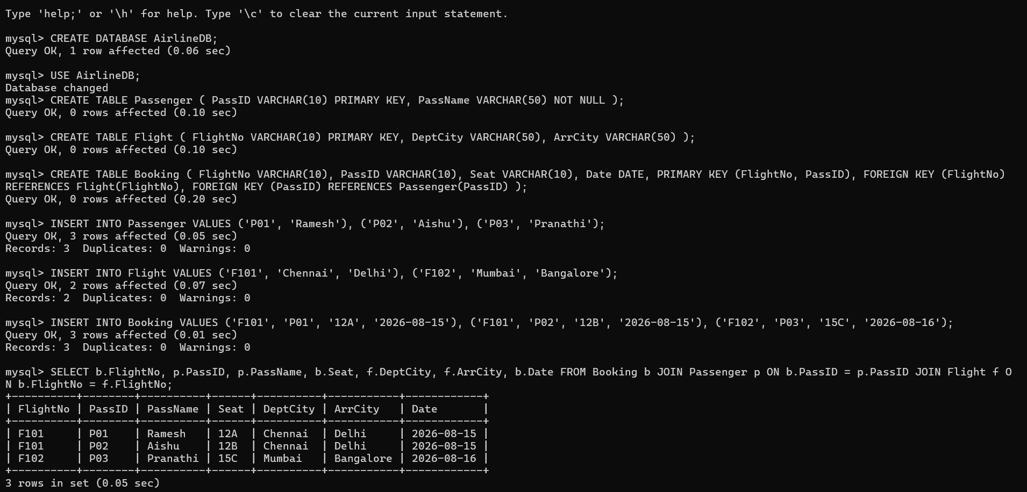
Result:
The original BOOKING relation contains partial dependencies because PassID determines PassName and FlightNo determines DeptCity and ArrCity. The relation is decomposed into PASSENGER, FLIGHT, and BOOKING. In each resulting relation, every determinant is a superkey. Therefore, the final design satisfies BCNF.

5. Analyze an HR system schema for a multinational company. Identify all functional and transitive dependencies and normalize to 3NF.
ANS:

Relation
EMPLOYEE(EmpID, EmpName, DeptID, DeptName, ManagerID)

Primary Key
EmpID

Functional Dependencies
EmpID → EmpName, DeptID, ManagerID
DeptID → DeptName

Transitive Dependency
EmpID → DeptID
DeptID → DeptName

Therefore:
EmpID → DeptName
So DeptName is transitively dependent on EmpID.

3NF Decomposition
EMPLOYEE(EmpID, EmpName, DeptID, ManagerID)
DEPARTMENT(DeptID, DeptName)

Keys
EMPLOYEE
PK = EmpID
FK = DeptID

DEPARTMENT
PK = DeptID

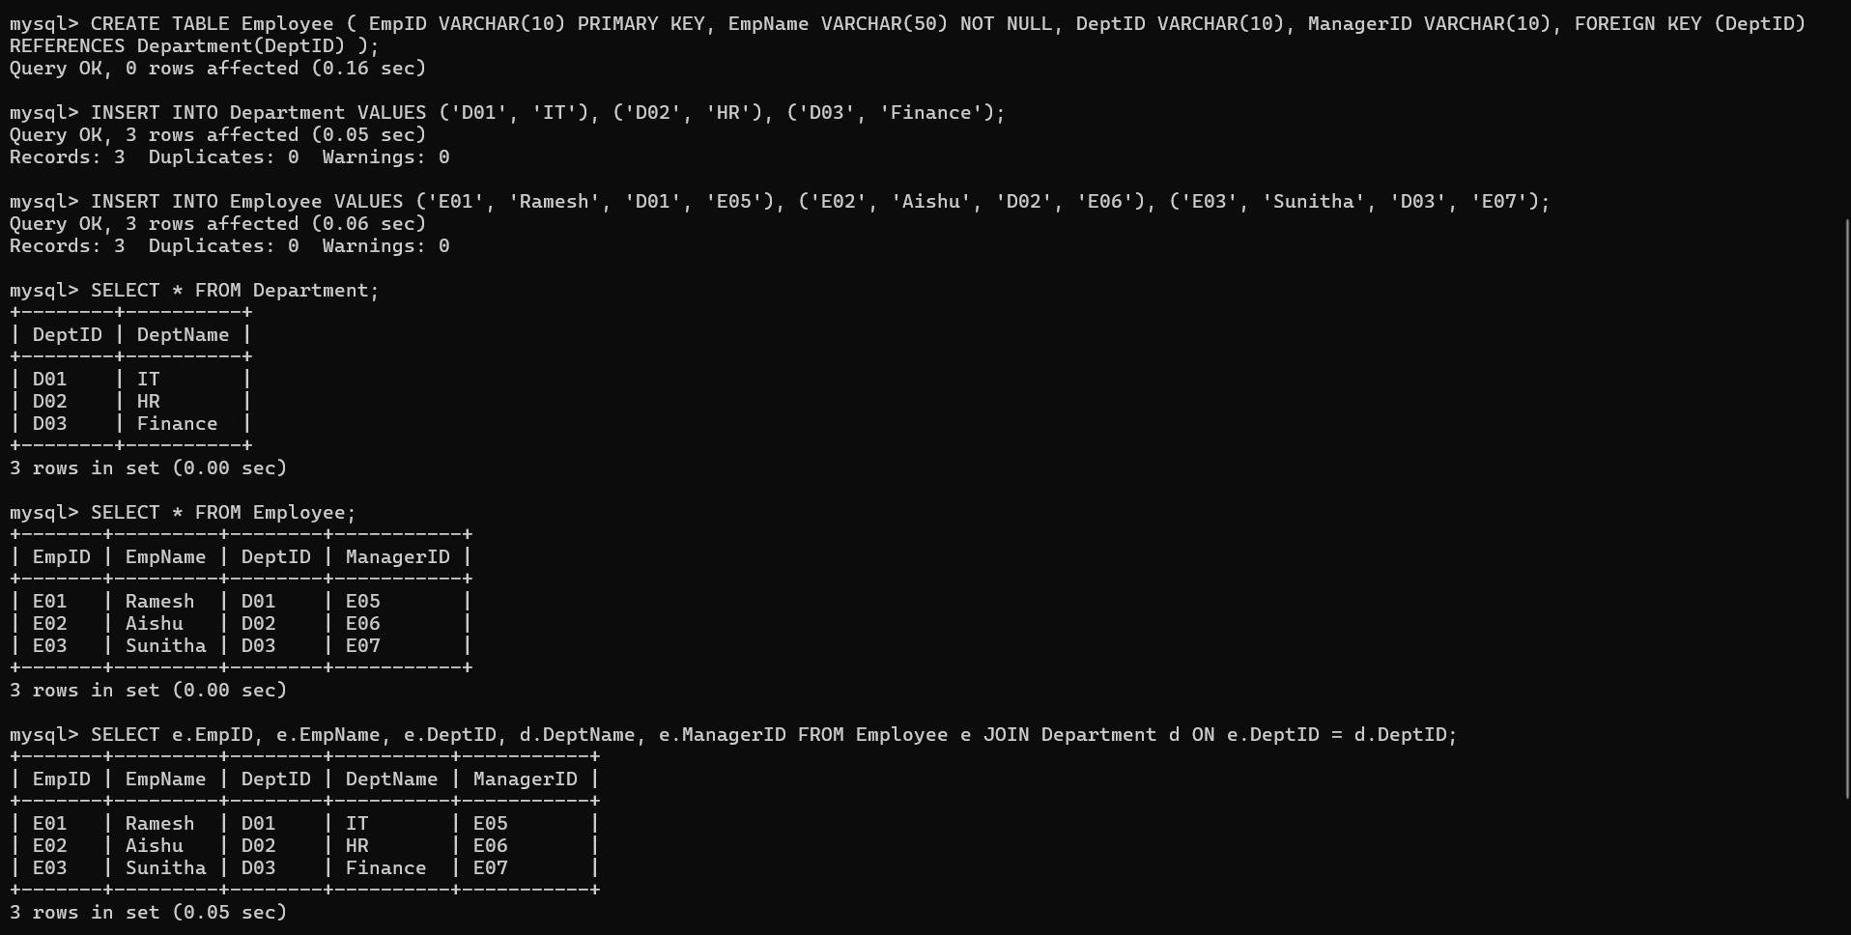

6. Library(MemberID, MemberName, BookID, Title, Author, Genre, BorrowDate). Identify MVDs and decompose to 4NF.
ANS:
Given Relation
LIBRARY(MemberID, MemberName, BookID, Title, Author, Genre, BorrowDate)

Functional Dependencies
MemberID → MemberName
BookID → Title, Author, Genre

Identify MVD
If a member can borrow multiple books independently:
MemberID →→ BookID
This means one MemberID can be associated with multiple BookID values independently.

Check 4NF
The relation contains a non-trivial MVD:
MemberID →→ BookID
but MemberID is not a superkey of the complete LIBRARY relation.
Therefore:
✗ LIBRARY is not in 4NF

4NF Decomposition
MEMBER
MEMBER(MemberID, MemberName)
PK = MemberID

BOOK
BOOK(BookID, Title, Author, Genre)
PK = BookID

BORROWING
BORROWING(MemberID, BookID, BorrowDate)
PK = (MemberID, BookID)

4NF Schema
MEMBER
----------------
MemberID (PK)
MemberName

BOOK
----------------
BookID (PK)
Title
Author
Genre

BORROWING
----------------
MemberID (FK)
BookID (FK)
BorrowDate

PK = (MemberID, BookID)

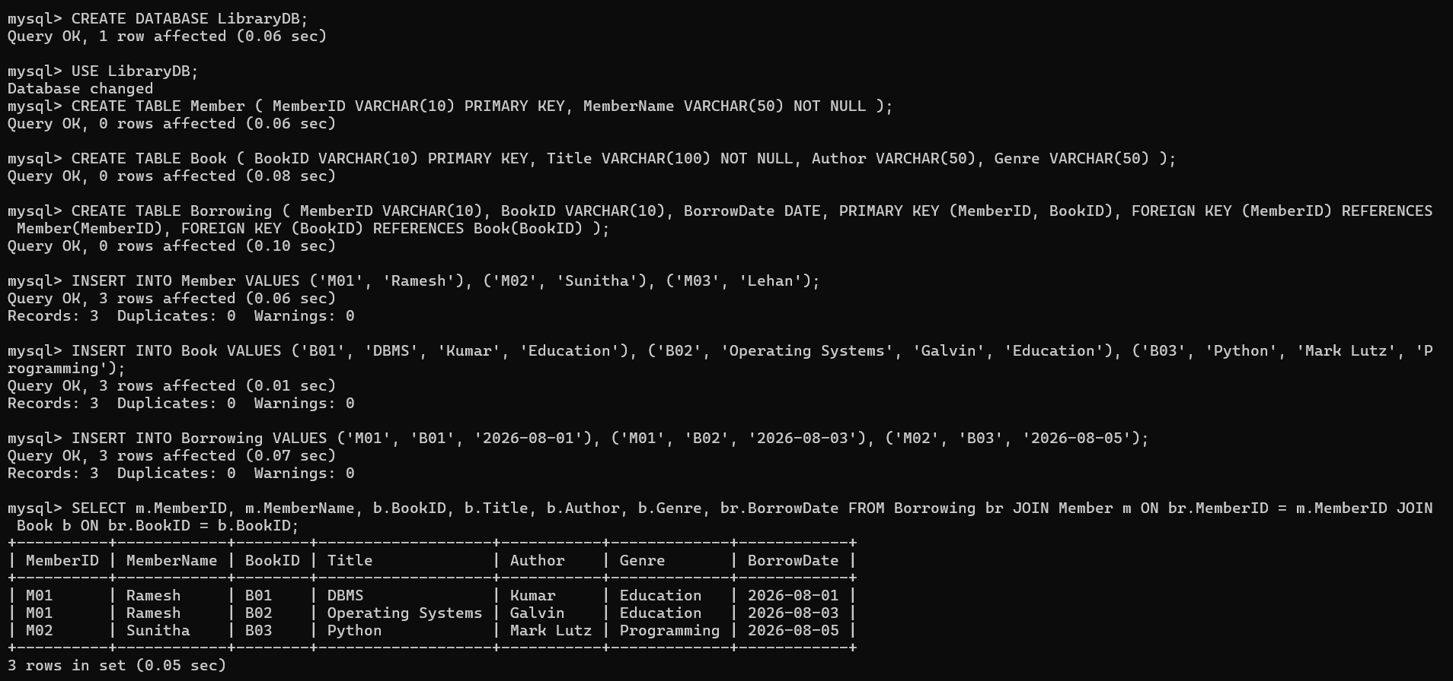
Result:
The MVD MemberID →→ BookID causes redundancy in the original relation. The relation is decomposed into MEMBER, BOOK, and BORROWING. The resulting relations eliminate the multivalued dependency and satisfy 4NF.

7. Analyze a telecom billing schema and identify all candidate keys, primary keys, and functional dependencies before normalization
ANS:
Candidate Keys
A candidate key is a minimal attribute or set of attributes that uniquely identifies each record.
Candidate Keys = To be identified from the given telecom schema

Primary Key
The primary key is one candidate key selected to uniquely identify each record.
Primary Key = One of the candidate keys

Functional Dependencies
A functional dependency (FD) shows that one attribute determines another.
Write them in the form:
A → B
For example, if CustomerID uniquely identifies a customer:
CustomerID → CustomerName, PhoneNo
If BillID uniquely identifies a bill:
BillID → CustomerID, BillDate, Amount
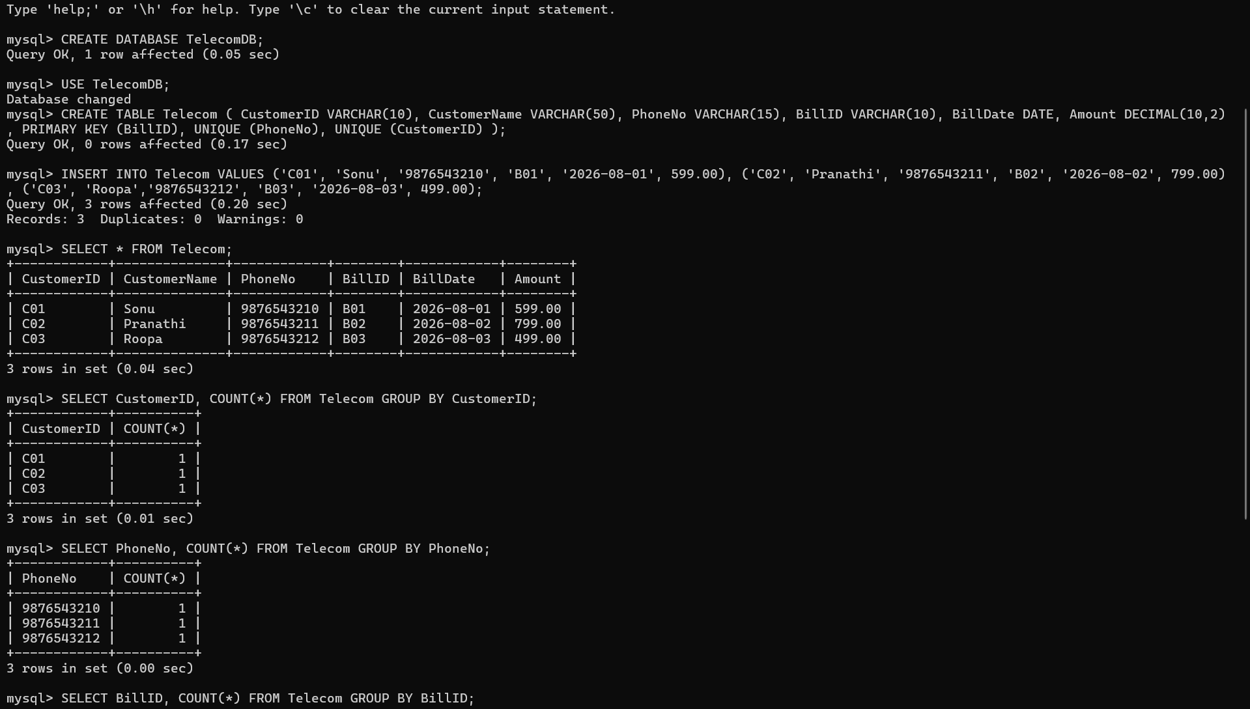
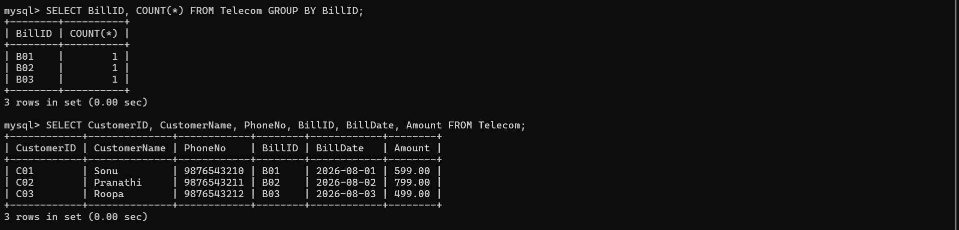
Result:
The SQL demonstrates candidate keys, primary key, uniqueness constraints, and the given functional dependencies before normalization.

8. A retail inventory system has Product(PID, PName, SupplierID, SupplierName, Category, Price, Warehouse). Apply complete normalization.
ANS:
Given Relation
PRODUCT(PID, PName, SupplierID, SupplierName, Category, Price, Warehouse)

Primary Key
Assume each product has a unique PID.
Primary Key = PID

Functional Dependencies
PID → PName, SupplierID, Category, Price, Warehouse
SupplierID → SupplierName
Therefore, there is a transitive dependency:
PID → SupplierID → SupplierName

Decompose
PRODUCT
PRODUCT(PID, PName, SupplierID, Category, Price, Warehouse)
PK = PID
SUPPLIER
SUPPLIER(SupplierID, SupplierName)
PK = SupplierID
SupplierID in PRODUCT is a foreign key.

BCNF
PRODUCT
PID → PName, SupplierID, Category, Price, Warehouse
PID is a key.
- BCNF

SUPPLIER
SupplierID → SupplierName
SupplierID is a key.
- BCNF
Therefore:
Final Design = BCNF

Final Normalized Schema

PRODUCT
-------------------------
PID PK
PName
SupplierID FK
Category
Price
Warehouse

SUPPLIER
-------------------------
SupplierID PK
SupplierName
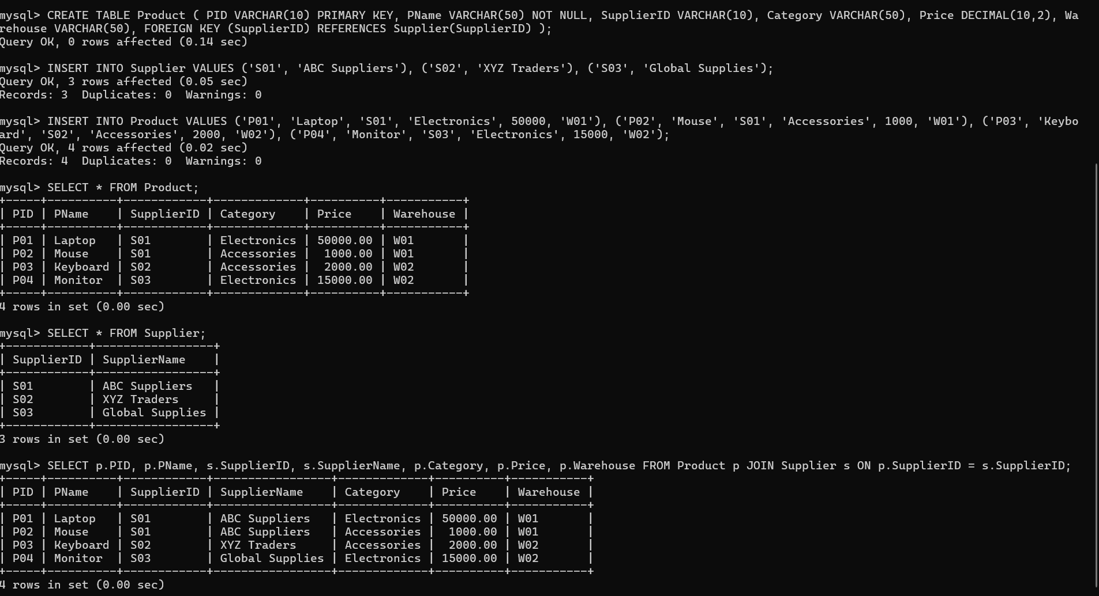

Result:
The original PRODUCT relation contains the transitive dependency PID → SupplierID → SupplierName. Therefore, supplier information is separated into a SUPPLIER table. The final PRODUCT and SUPPLIER relations eliminate redundancy and satisfy 3NF; under the stated dependencies, they also satisfy BCNF.

9. Study the given poorly normalized schema for a School ERP and propose a fully normalized design up to BCNF with justification.
ANS:
Poorly Normalized Schema
SCHOOL_ERP(
StudentID, StudentName, ClassID, ClassName,
TeacherID, TeacherName, SubjectID, SubjectName, Marks
)

Functional Dependencies
StudentID → StudentName, ClassID
ClassID → ClassName, TeacherID
TeacherID → TeacherName
SubjectID → SubjectName
(StudentID, SubjectID) → Marks

Normalization
1NF: Atomic values → ✓
2NF: Remove partial dependencies:
STUDENT(StudentID, StudentName, ClassID)
SUBJECT(SubjectID, SubjectName)
ENROLLMENT(StudentID, SubjectID, Marks)
3NF: Remove transitive dependencies:
CLASS(ClassID, ClassName, TeacherID)
TEACHER(TeacherID, TeacherName)

Final BCNF Design
STUDENT(StudentID PK, StudentName, ClassID FK)
CLASS(ClassID PK, ClassName, TeacherID FK)
TEACHER(TeacherID PK, TeacherName)
SUBJECT(SubjectID PK, SubjectName)
ENROLLMENT(StudentID FK, SubjectID FK, Marks,
PK = StudentID + SubjectID)

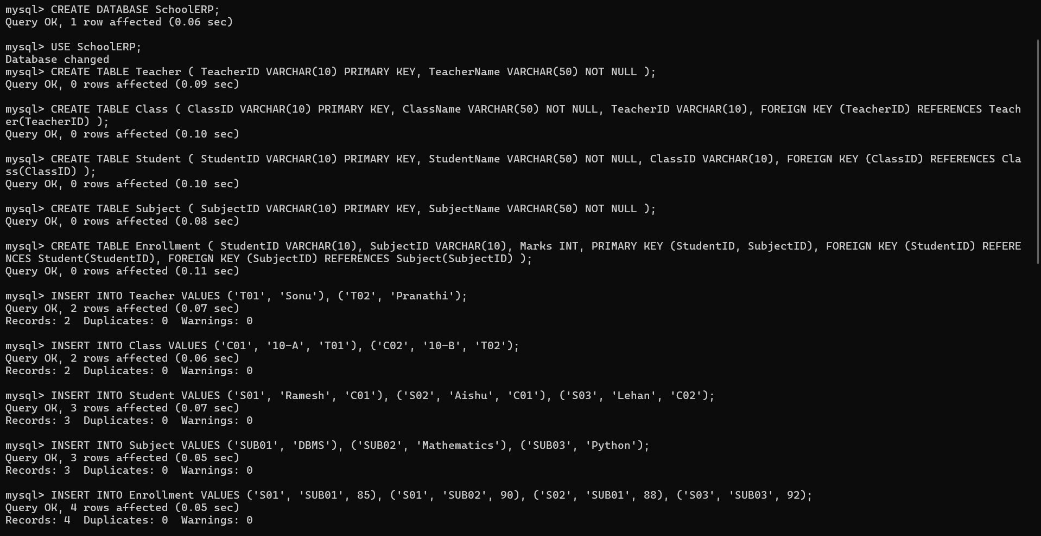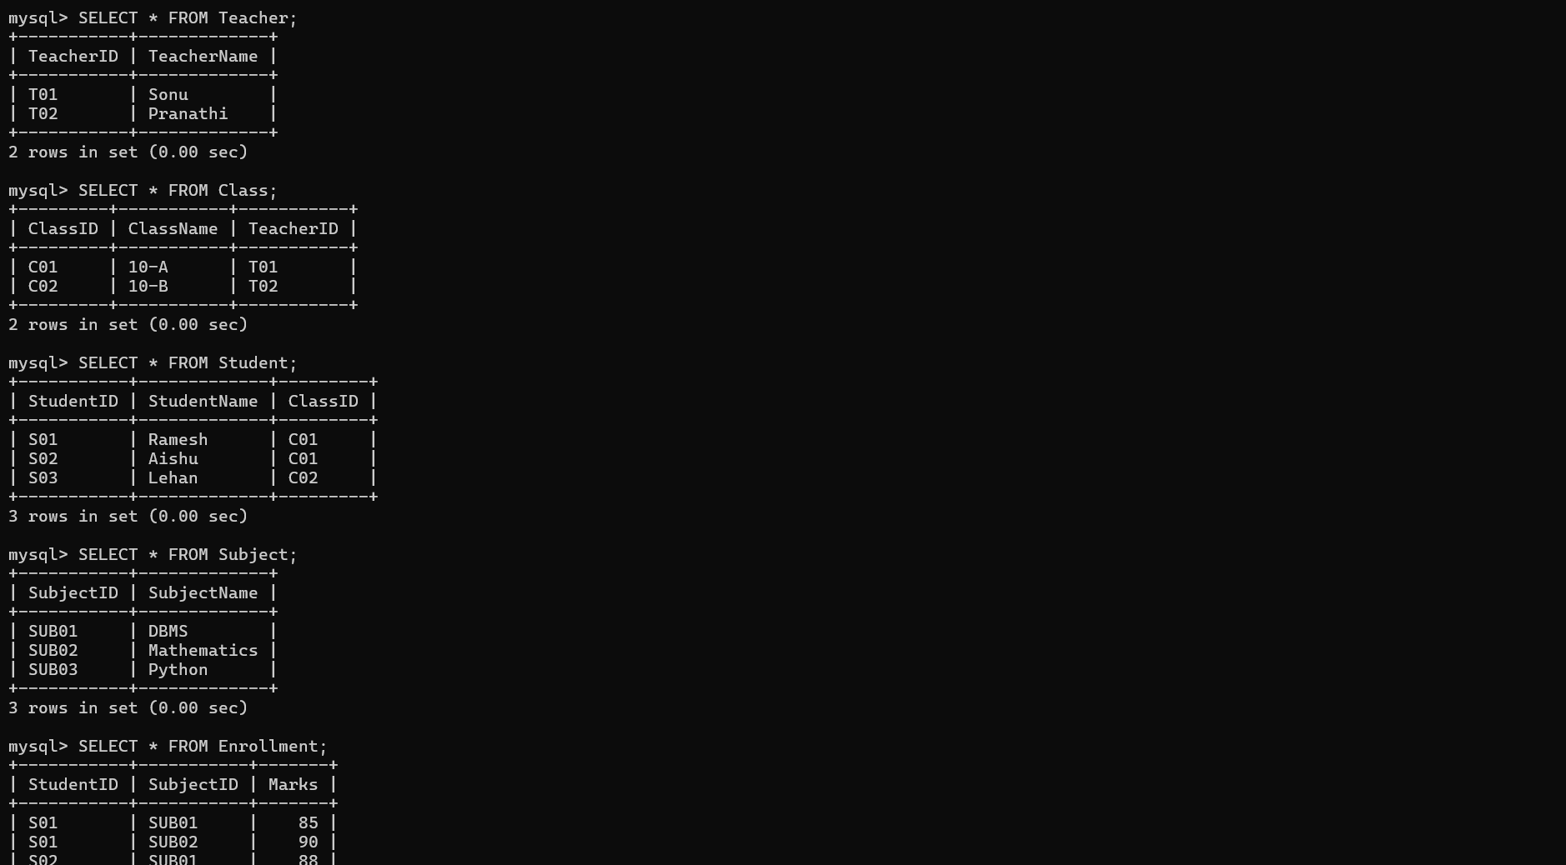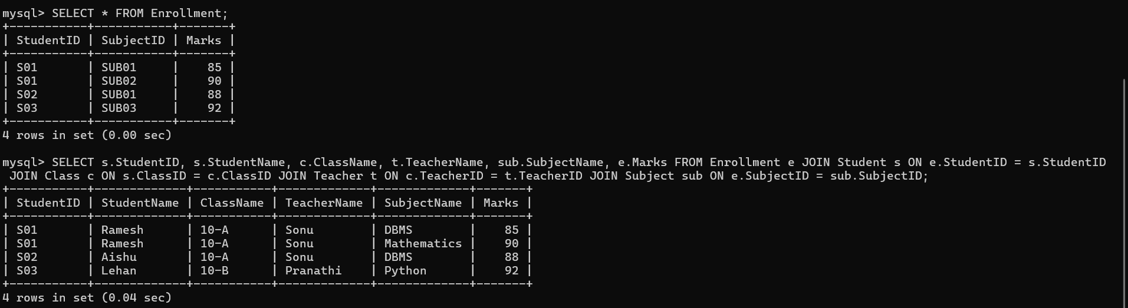
Result:
The poorly normalized School ERP data is decomposed into TEACHER, CLASS, STUDENT, SUBJECT, and ENROLLMENT. Primary and foreign keys maintain relationships, redundancy is reduced, and the final design satisfies the proposed BCNF structure.

10. Given a movie streaming platform schema, identify join dependencies and decompose to 5NF with lossless-join verification.
ANS:

Functional Dependencies
MovieID → MovieTitle
ActorID → ActorName
PlatformID → PlatformName
The main relationship is:
(MovieID, ActorID, PlatformID)

Join Dependencies
The three independent relationships are:
(MovieID, ActorID)
(MovieID, PlatformID)
(ActorID, PlatformID)
Therefore, the original relation can be decomposed into:
MOVIE_ACTOR(MovieID, ActorID)
MOVIE_PLATFORM(MovieID, PlatformID)
ACTOR_PLATFORM(ActorID, PlatformID)

5NF Decomposition
MOVIE
MOVIE(MovieID, MovieTitle)

ACTOR
ACTOR(ActorID, ActorName)

PLATFORM
PLATFORM(PlatformID, PlatformName)

MOVIE_ACTOR
MOVIE_ACTOR(MovieID, ActorID)

MOVIE_PLATFORM
MOVIE_PLATFORM(MovieID, PlatformID)

ACTOR_PLATFORM
ACTOR_PLATFORM(ActorID, PlatformID)

Normalization
Original Relation
↓
1NF
↓
2NF
↓
3NF
↓
BCNF
↓
5NF
↓
Remove Join Dependencies
↓
Final Relations

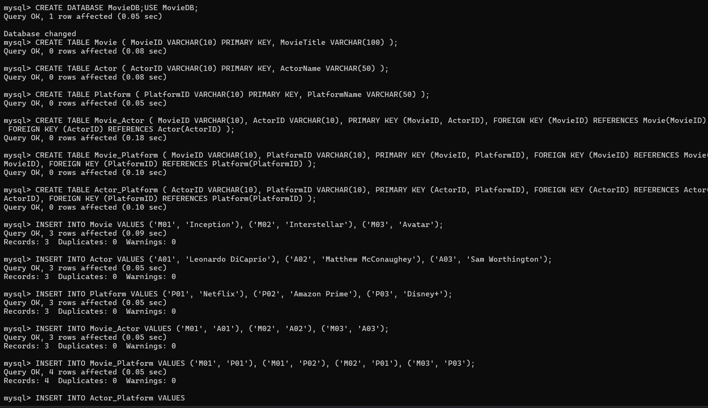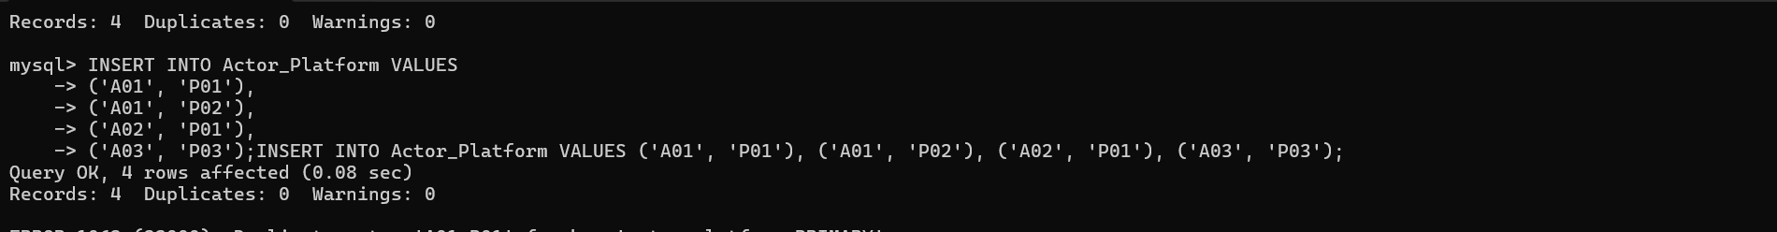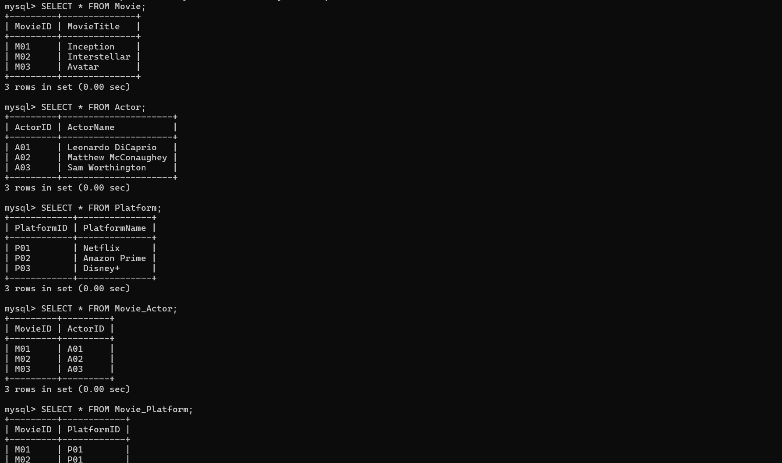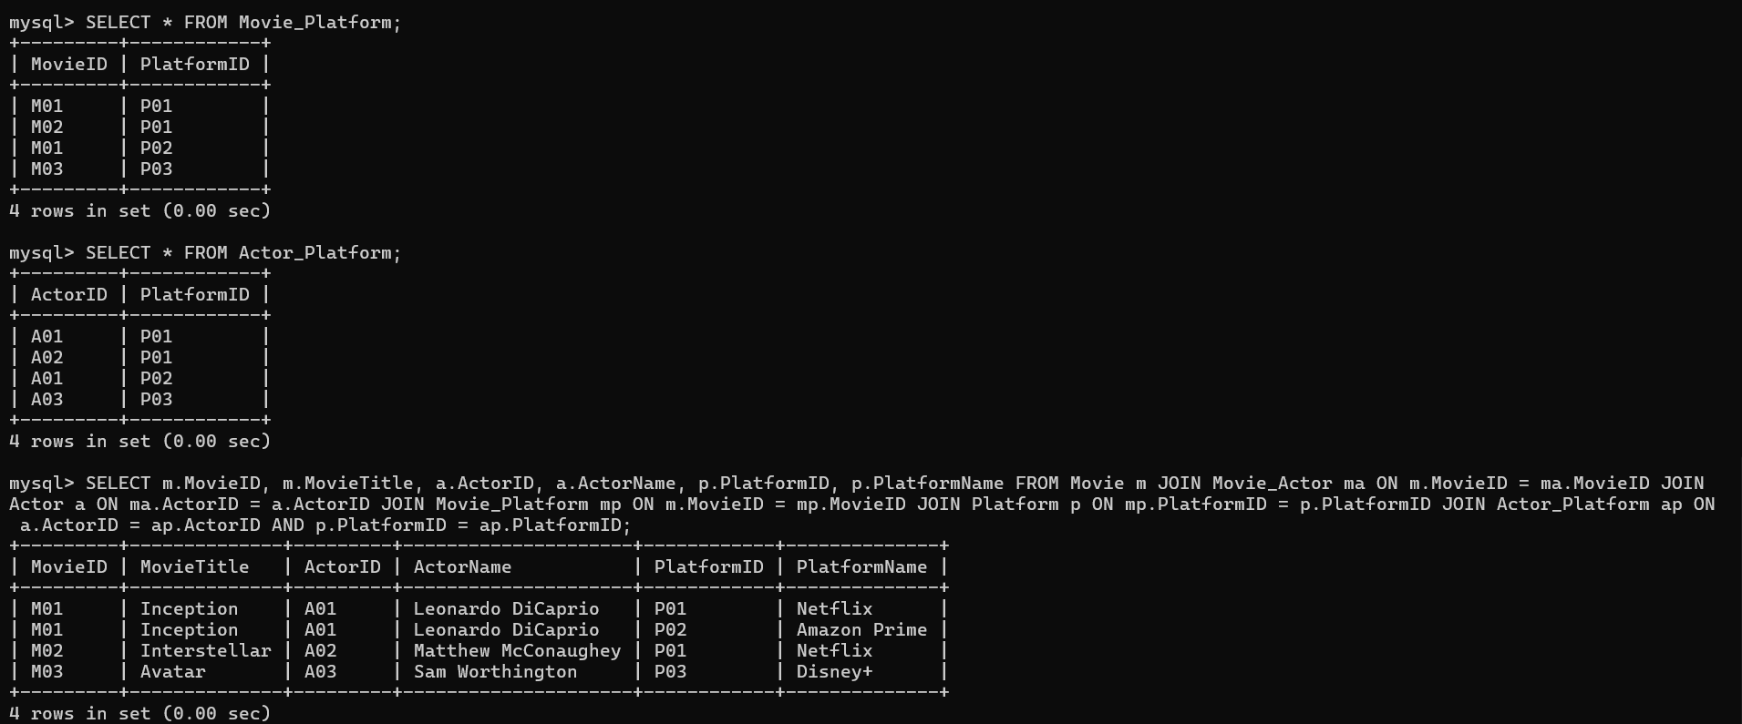

Result:
The final JOIN successfully reconstructs the movie, actor, and platform information from the decomposed tables, demonstrating the intended lossless-join reconstruction for the proposed 5NF design.

